Assignment 2- Case Study

Stage 3 Lab Activities

SmartCare Domain Modelling
AI OFF -> AI ON -> COMPARE -> VERIFY | 1 hour
Completed by: Mani (u3263841)

A - Requirements Review
Highlight nouns, verbs and business rules in SmartCare v0.2.
Nouns (candidate concepts)
patient, practitioner, appointment, patient ID, practitioner ID, given name, family name, date of birth, role, date, start time, status, appointment history, practitioner’s day list, staff member, receptionist, clinic.
Verbs (candidate behaviour)
create, retrieve, display, update, link, reject, save nothing, record, change, cancel, retain, list, exclude, reschedule, re-run the check.
Business rules (the constraints that matter most)
- FR-06: a practitioner cannot hold two Booked appointments at the same date and start time. This is the rule the whole system exists for.
- FR-05: an appointment links exactly one patient and exactly one practitioner. Not one or more — exactly one of each.
- FR-07: status is one value from a fixed list of three.
- FR-09 and NFR-05: cancelling changes status and keeps the record. Nothing is permanently deleted and a patient ID is never reused.
- FR-10 versus FR-11: cancelled appointments are included in a patient’s history but excluded from a practitioner’s day list. Same data, two different filters.
- NFR-03: booking rules must sit in a module with no interface code.
Two words in that list are traps. “Clinic” and “database” read like nouns worth modelling, but one has a single instance under assumption A-01 and the other is a storage choice rather than something the client talked about.

B - Candidate Classes
Record candidate concepts, supporting requirements, state and behaviour.
Each candidate is listed with the requirements that support it, the state it would hold and the behaviour it would carry. The test for promoting something to a class: does it have state worth storing, behaviour of its own, and an identity that persists?
Patient — FR-01, FR-02, FR-03
State: patient_id, given_name, family_name, date_of_birth. Behaviour: update its own details; report a display name.
Decision: Class. Identity persists between visits.
Practitioner — FR-04, FR-11
State: practitioner_id, name, role. Behaviour: report a display name.
Decision: Class. Same test as Patient.
Appointment — FR-05, FR-07 to FR-12
State: appointment_id, patient, practitioner, date, start_time, status. Behaviour: cancel; change status; report whether it clashes; move to a new time.
Decision: Class. The concept most of the requirements are about.
AppointmentBook — FR-06, FR-10, FR-11, FR-12, NFR-03
State: the collection of every appointment, cancelled ones included. Behaviour: refuse a clashing booking; create one that passes; answer the two list queries; approve a reschedule.
Decision: Class. FR-06 needs a view across every appointment, which no single Appointment has.
Status — FR-07
State: one of Booked, Completed, Cancelled. Behaviour: none.
Decision: Attribute, not a class. No behaviour of its own, so a Status class would be an empty wrapper.
Name — FR-01, FR-04
State: text. Behaviour: none.
Decision: Attribute. No identity — two patients with the same name are still two patients.
Cancellation — FR-09
State: none beyond the status value. Behaviour: none.
Decision: Not a class. It is an event already covered by a status change. Revisit if OQ-04 or OQ-08 come back needing who cancelled and when.
Clinic — none directly
State: would hold the other collections. Behaviour: none.
Decision: Not in v0.3. A-01 gives it exactly one instance and no rule of its own.
Database — none
State: n/a. Behaviour: n/a.
Decision: Not a domain concept. Storage is an implementation decision the brief never mentions.

C - CRC Cards
Create CRC cards for Patient, Practitioner and Appointment.
Patient
Responsibilities
• Know its own patient ID, given name, family name and date of birth (FR-01).
• Update its own details when they change (FR-03).
• Report a display name for confirmations (FR-02, AC-01).
• Never let its patient ID change once set (NFR-05).
Collaborators
• Appointment — holds a reference to it (FR-05).
• AppointmentBook — asked for this patient’s history (FR-10).
Practitioner
Responsibilities
• Know its own practitioner ID, name and role (FR-04).
• Report a display name for the booking confirmation (AC-01).
• Never let its practitioner ID change once set.
Collaborators
• Appointment — each one names exactly one practitioner (FR-05).
• AppointmentBook — asked for this practitioner’s day list (FR-11).
Appointment
Responsibilities
• Know the one patient, one practitioner, date and start time it links (FR-05).
• Keep its status within Booked, Completed and Cancelled (FR-07).
• Change its own status when asked (FR-08).
• Cancel itself by setting status, never by deleting (FR-09, NFR-05).
• Answer whether it clashes with a given practitioner, date and time (FR-06).
• Move itself once the book has approved the new time (FR-12).
Collaborators
• Patient and Practitioner — held as references.
• AppointmentBook — creates it and approves any move (FR-06, FR-12).
AppointmentBook (the fourth card I added)
Responsibilities
• Hold every appointment, cancelled ones included (FR-09, NFR-05).
• Refuse a booking that clashes with an existing Booked one (FR-06).
• Create the appointment once the check passes (FR-05).
• Return a patient’s appointments in date order, cancelled included (FR-10).
• Return a practitioner’s appointments for a date, cancelled excluded (FR-11).
• Re-run the clash check before allowing a reschedule (FR-12).
Collaborators
• Appointment — creates and holds them.
• Patient and Practitioner — taken as arguments, never stored twice.
The brief only asked for three cards. I added the fourth because FR-06 kept ending up with no owner — writing the cards is what made that obvious.

D - UML Model
Draw classes, attributes, operations, associations and multiplicities.
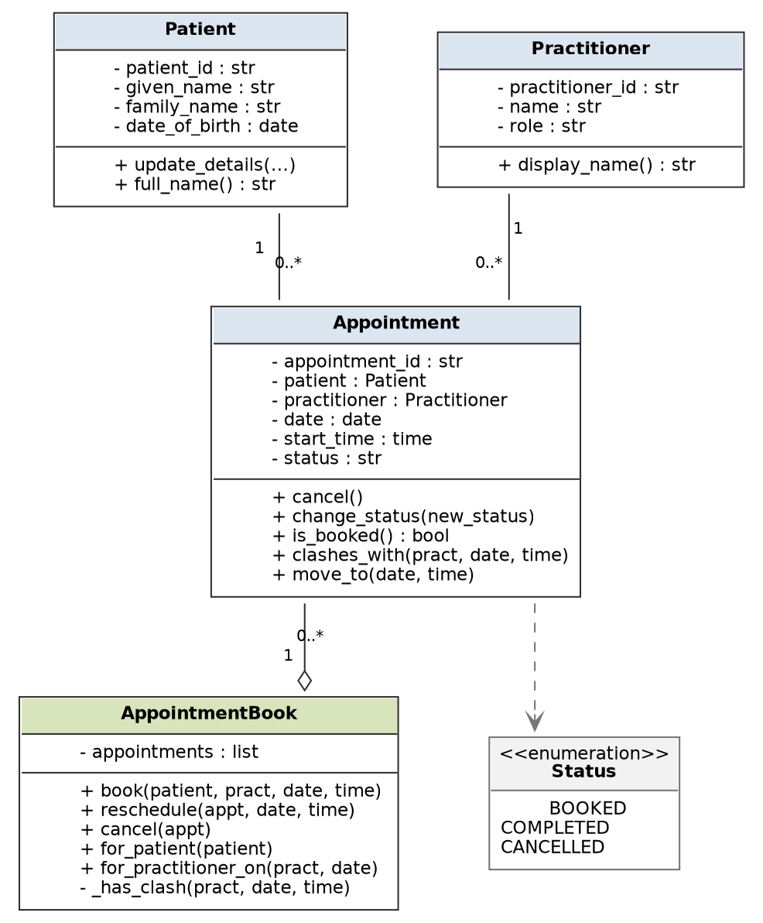
Figure 1 — SmartCare v0.3 domain model.
- Patient 1 — 0..* Appointment and Practitioner 1 — 0..* Appointment. The 1 ends come straight from FR-05. Plain associations, not composition, because NFR-05 rules out appointments disappearing when anything else does.
- AppointmentBook has an open diamond to Appointment: it holds and creates them, but they are not destroyed with it.
- The dashed arrow to Status is a dependency. Status is a set of allowed values for an attribute (FR-07), not an object Appointment owns.
- FR-06 is not on the diagram. “One Booked appointment per practitioner per date and time” is a business rule enforced in _has_clash(). Putting 0..1 on the association would wrongly say a practitioner can only ever have one appointment.

E - AI Design Review
Ask AI to suggest classes and relationships using only confirmed requirements; require supporting requirement IDs.
Prompt used
“Using only the confirmed requirements in SmartCare v0.2 below, suggest domain classes and relationships. For every class and every relationship, cite the requirement IDs that support it. Do not introduce capabilities that no requirement states. Where you are inferring rather than citing, say so.”
What came back
S1: Patient, Practitioner and Appointment as classes.
Requirement IDs it gave: Cited FR-01 to FR-05. Correct.
S2: PatientManager, PractitionerManager and AppointmentManager to hold the collections.
Requirement IDs it gave: Cited FR-06 for the third only. The first two were offered with no ID at all.
S3: Status as a class with BookedStatus, CompletedStatus and CancelledStatus subclasses.
Requirement IDs it gave: Cited FR-07.
S4: Patient should own a list of its own appointments.
Requirement IDs it gave: Cited FR-10.
S5: Appointment should hold a list of patients so group sessions are possible.
Requirement IDs it gave: No ID cited. Offered as “a common extension”.
S6: A NotificationService so patients are told when an appointment changes.
Requirement IDs it gave: No ID cited.
S7: Appointment.cancel() should delete the record to keep the list small.
Requirement IDs it gave: No ID cited, and offered as a performance improvement.
Worth noting how uneven the citations were. Where the tool had a real requirement it named one; where it did not, it switched to phrases like “commonly” and “you may want to”. That shift in wording turned out to be a reliable signal that nothing was behind the suggestion.

F - Compare and Decide
Record at least one accepted, modified and rejected AI suggestion.
At least one accepted, one modified and one rejected, as asked. I have recorded all seven so the reasoning is traceable.
S1 — Accepted
It matches what I had already worked out with AI off, and the cited IDs check out against v0.2. Model change: none needed.
S2 — Modified
Split the suggestion in two. PatientManager and PractitionerManager were dropped: they would only wrap getters and setters, leaving Patient and Practitioner as bags of data with no behaviour, and no requirement needs a rule spanning several patients. The third was kept, because FR-06 genuinely needs a view across every appointment. I renamed it AppointmentBook, since “Manager” describes nothing. Model change: one class added, two rejected.
S3 — Rejected
FR-07 asks for one value from a fixed list. Subclasses would add four classes and a state machine for a field that never behaves differently depending on its value. The ID was cited correctly but read far past what it says. Model change: none — status stays an attribute with an enumeration.
S4 — Modified
FR-10 is real, so the need is genuine, but putting the list on Patient as well as AppointmentBook creates two copies that can drift apart. Model change: FR-10 is answered by AppointmentBook.for_patient() and Patient holds no list.
S5 — Rejected
FR-05 says exactly one patient. Going to 1..* would break AC-01 and leave the FR-06 clash rule ambiguous about which patient it applies to. Model change: none.
S6 — Rejected
Notifications were ruled out of scope in v0.2, and SMS reminders were already rejected in the Week 5 AI review for the same reason. This is the second time a tool has suggested it, which does not make it any better evidenced. Model change: none.
S7 — Rejected
It contradicts FR-09 and NFR-05 outright. This was the one I had to be most careful with, because “keep the list small” sounds like good practice until you check it against the requirement that says nothing is deleted. Model change: none — no class has a delete method at all.
Scoreboard: one accepted, two modified, four rejected. The two that survived in any form were the only two with a requirement ID that held up when I checked it.

G - Python Skeletons
Create simple Patient, Practitioner and Appointment class skeletons.
Attributes and method names match the diagram exactly. Every method carries the requirement it will satisfy, so the trace survives into the code.
"""SmartCare v0.3 - domain class skeletons.

Traced to the v0.2 requirements. Behaviour is not implemented yet;
each method records the requirement it will have to satisfy.
"""

# FR-07: status is one value from a fixed list.
BOOKED = "Booked"
COMPLETED = "Completed"
CANCELLED = "Cancelled"
VALID_STATUSES = (BOOKED, COMPLETED, CANCELLED)

class Patient:
"""One person the clinic treats. FR-01 to FR-03."""

def __init__(self, patient_id, given_name, family_name, date_of_birth):
self.patient_id = patient_id # FR-01, never reused (NFR-05)
self.given_name = given_name
self.family_name = family_name
self.date_of_birth = date_of_birth

def update_details(self, given_name, family_name, date_of_birth):
"""FR-03. patient_id is deliberately not a parameter."""
pass

def full_name(self):
"""FR-02 and AC-01."""
pass

class Practitioner:
"""Someone who sees patients. FR-04."""

def __init__(self, practitioner_id, name, role):
self.practitioner_id = practitioner_id
self.name = name
self.role = role

def display_name(self):
"""AC-01, for the booking confirmation."""
pass

class Appointment:
"""One patient with one practitioner at one date and time. FR-05."""

def __init__(self, appointment_id, patient, practitioner,
date, start_time):
self.appointment_id = appointment_id
self.patient = patient # FR-05: exactly one
self.practitioner = practitioner # FR-05: exactly one
self.date = date
self.start_time = start_time
self.status = BOOKED # new appointments start Booked

def change_status(self, new_status):
"""FR-08. Must refuse anything outside VALID_STATUSES."""
pass

def cancel(self):
"""FR-09. Sets status only - never deletes (NFR-05)."""
pass

def is_booked(self):
"""Helper for FR-06 and FR-11."""
pass

def clashes_with(self, practitioner, date, start_time):
"""FR-06. True only if this one is Booked and all three match."""
pass

def move_to(self, date, start_time):
"""FR-12. Called only after the book confirms there is no clash."""
pass

class AppointmentBook:
"""Owns every appointment and enforces the clash rule.

FR-06, FR-10, FR-11, FR-12. Kept free of any print() or input()
so the rules can be tested without the interface (NFR-03, NFR-04).
"""

def __init__(self):
self.appointments = [] # cancelled ones stay in here (NFR-05)

def book(self, patient, practitioner, date, start_time):
"""FR-05 and FR-06. Returns the new Appointment, or refuses."""
pass

def reschedule(self, appointment, date, start_time):
"""FR-12. Re-checks, then asks the appointment to move itself."""
pass

def cancel(self, appointment):
"""FR-09."""
pass

def for_patient(self, patient):
"""FR-10. Date order, cancelled ones included."""
pass

def for_practitioner_on(self, practitioner, date):
"""FR-11. Cancelled ones excluded."""
pass

def _has_clash(self, practitioner, date, start_time):
"""FR-06. The one rule no single Appointment can check alone."""
pass

# Note: there is deliberately no remove() or delete() anywhere
# in this file. NFR-05 says nothing is permanently deleted, so
# the safest way to enforce that is to give the code no way to.

H - Consistency Check
Check model-code consistency; do not implement full behaviour yet.
What matches
- Four classes in the diagram, four classes in the file, same names.
- Every attribute in the diagram appears in the matching __init__, in the same order.
- Every operation in the diagram appears as a method with the same name and the same parameters. _has_clash() is private in both, shown with a minus sign on the diagram and a leading underscore in the code.
- Appointment stores patient and practitioner as single references, which is the 1 end of both associations. AppointmentBook stores a list, which is the 0..* end. Patient and Practitioner store no list, matching the decision not to hold the same data twice.
- No class has a delete or remove method, which is how NFR-05 shows up in the code.
- No print() or input() anywhere in the file, which is NFR-03.
Differences I had to accept
- The diagram shows Status as an <<enumeration>>. The code uses three module-level constants and a VALID_STATUSES tuple instead, because we have not covered the enum module yet. The constraint is the same; the mechanism is simpler.
- The diagram shows return types on some operations. Python does not require them, so they are not in the code. If we add type hints later, they should match the diagram.
Gaps this check found
- appointment_id is in both the diagram and the code, but no v0.2 requirement asks for one. I inferred it from FR-08, FR-09 and AC-03, which all need a way to name a specific appointment. Logged as MQ-04 rather than pretending it was stated.
- FR-02 needs a collection of patients to search, and nothing in the file holds one yet. For v0.3 that is a plain dictionary in the application entry point, because unlike FR-06 there is no rule to enforce over it. Logged as MQ-01.
No behaviour is implemented yet, which is what Part H asked for. Every method body is pass with a docstring naming its requirement, so the next stage is filling them in rather than deciding what they should do.

Reflection
What modelling decision was hardest? Where did AI over-design? What evidence supported your final choices?
The hardest decision was whether the fourth class should exist at all. We had been warned off manager classes, so my first model had only the three obvious ones, and FR-06 kept ending up with nowhere to live. An appointment cannot see the other appointments, so it cannot tell whether it clashes with one. Writing the CRC cards is what settled it: the responsibility had no owner. What changed my mind was realising the warning is about classes that only wrap another object’s data, not about classes that own a collection and protect a rule across it. So AppointmentBook stayed and PatientManager did not.
The AI over-designed in two directions. It added structure nothing needed — subclasses for each status value, a ScheduleEngine, a ClinicController — and it re-suggested notifications that had already been ruled out of scope in v0.2. It also suggested deleting cancelled records to keep the list small, which directly contradicts FR-09 and NFR-05. That one was the most useful to catch, because it sounded like good practice right up until I checked it.
The evidence behind every final choice is a requirement ID from v0.2. Patient, Practitioner and Appointment come from FR-01 to FR-05. AppointmentBook comes from FR-06, FR-10, FR-11 and FR-12. Status stayed an attribute because FR-07 describes a value, not a thing that behaves. Where I could not find an ID, such as appointment_id, I logged it as my own inference instead of writing it up as a requirement.

